DAY 15 | Implementation of NAND Gate using NOT and AND Gates using Verilog HDL
Introduction: A NAND gate is one of the most important universal gates in digital electronics because it can be used to implement any Boolean function. Instead of using a predefined NAND gate, it can also be constructed using basic logic gates based on De Morgan's Theorem. In this implementation, the input signals are first inverted using NOT gates, and the complemented outputs are then applied to an AND gate to obtain the NAND function. The complete design is implemented using Verilog HDL and verified using Xilinx Vivado through RTL synthesis and simulation.
Implementation of NOT Gate
Introduction: The NOT gate is the first stage in the implementation of the NAND gate. It inverts each input signal independently to generate their complemented values. These inverted signals are required according to De Morgan's Theorem and are later applied to the AND gate to obtain the final NAND output. Verifying the NOT gate separately ensures that each input is complemented correctly before proceeding to the next stage.
Design Implementation :The NOT gate using the assign statement and the logical NOT (~) operator. Each input is inverted independently, producing complemented outputs that serve as inputs to the AND gate.
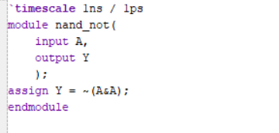
Testbench: The testbench verifies the functionality of the NOT gate by applying all possible input values (0 and 1). The simulation confirms that the output is always the logical complement of the input, validating the correct operation of the inverter.
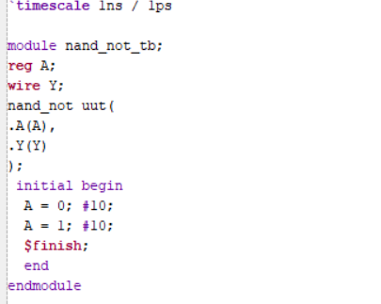
RTL Schematic
The RTL schematic generated by Xilinx Vivado shows the synthesized hardware implementation of the NOT gate. It confirms that the input signal is correctly inverted according to the Verilog HDL design.
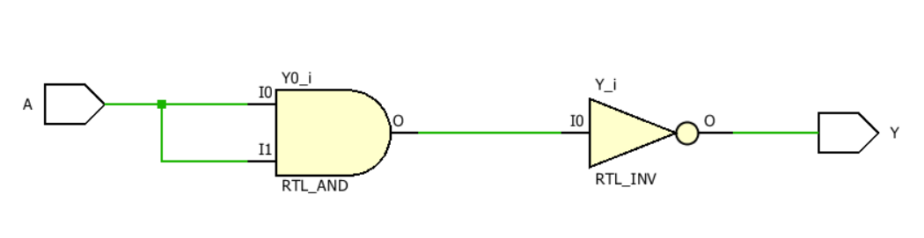
Simulation Waveform: The simulation waveform verifies the behavior of the NOT gate for all input conditions. When the input is LOW, the output becomes HIGH, and when the input is HIGH, the output becomes LOW, confirming the correct inverter operation.
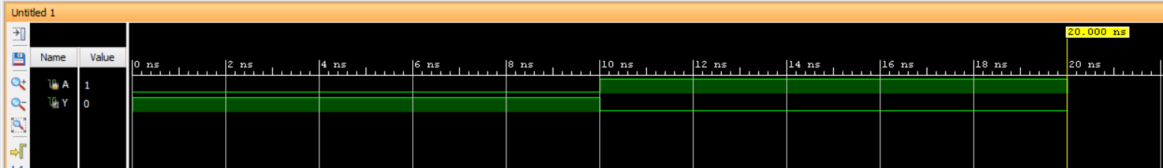
Implementation of AND Gate
Introduction: The AND gate is the second stage in the NAND gate implementation. It receives the complemented outputs generated by the NOT gates and performs the logical AND operation. According to De Morgan's Theorem, combining the complemented inputs through an AND gate produces the equivalent NAND function.
Design Implementation : The AND gate using the assign statement and the logical AND (&) operator. The inverted outputs from the NOT gates are used as the inputs to the AND gate to generate the final NAND output.
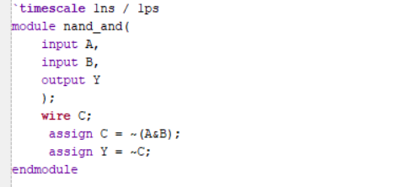
Testbench: The testbench verifies the functionality of the AND gate by applying all possible combinations of the complemented input signals. The simulation confirms that the generated output matches the expected NAND logic.
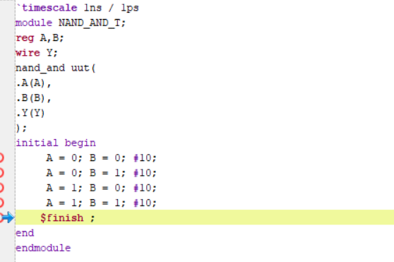
RTL Schematic: The RTL schematic generated by Xilinx Vivado represents the synthesized implementation of the AND gate connected to the outputs of the NOT gates. It verifies the correct hardware realization of the NAND gate.
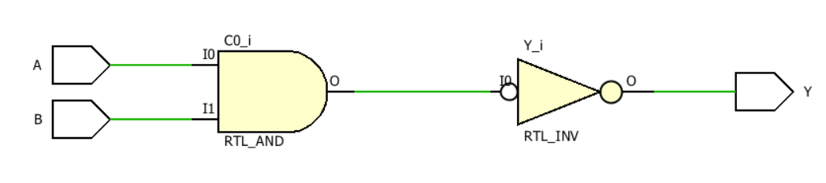
Simulation Waveform: The simulation waveform confirms that the AND gate correctly processes the complemented inputs generated by the NOT gates. The output waveform matches the expected NAND gate behavior for every input combination.
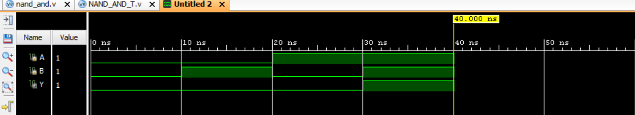
Observation
- Successfully implemented the NAND gate using NOT and AND gates.
- Verified the functionality of the NOT gate and the AND gate individually.
- Confirmed that the combined implementation follows De Morgan's Theorem.
- The RTL schematic and simulation waveform validate the correct operation of the complete design.

#PHANEENDRA.SINGUDASU

